Tarea 2: Correo electrónico

Nombre de la lectura: Encuesta sobre la belleza
Autor: Andrew Mayek
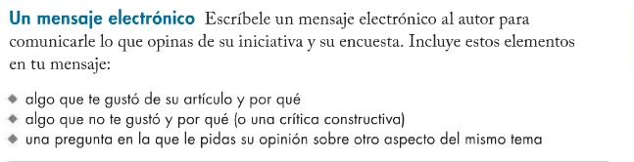
Estimado(a), ___________________________,

____________________________________________________________________________________________________________________________________________________________________________________________________________________________________________________________________________________________________________________________________________________________________________________________________________________________________________________________________________________________________________________________________________________________
______________________________________________________________________________________________________________________________________________________________________________________________________________________________________________________________________________
______________________________________________________________________________________________________________________________________________________________________________________________________________________________________________________________________________
______________________________________________________________________________________________________________________________________________________________________________________________________________________________________________________________________________
______________________________________________________________________________________________________________________________________________________________________________________________________________________________________________________________________________
______________________________________________________________________________________________________________________________________________________________________________________________________________________________________________________________________________
______________________________________________________________________________________________________________________________________________________________________________________________________________________________________________________________________________
______________________________________________________________________________________________________________________________________________________________________________________________________________________________________________________________________________
______________________________________________________________________________________________________________________________________________________________________________________________________________________________________________________________________________
______________________________________________________________________________________________________________________________________________________________________________________________________________________________________________________________________________
____________________________________________________________________________________________________________________________________________________________________________________

Sinceramente,

