Colaborative Station:

In this station you will practice recording your voice. Below are some instructions you will need to complete this assignment.

How to record sound on a mac.
If you have Mac OS X 10.6 (Snow Leopard) or later, you may use the built in QuickTime 10 player.
- Open QuickTime Player from your Applications folder.
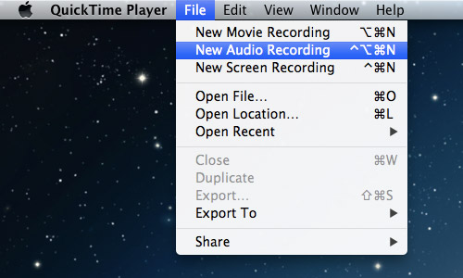
- Open the file menu and select New Audio Recording.
You will see a very simple user interface that is similar to Windows Sound Recorder. (Picture above)
You may click on the down arrow to select the microphone input, quality and save destination. I suggest saving it on the desktop of easy access.
- Microphone volume is adjustable with the slider under the record button.
- You must choose built-in input (line-in) to use the microphone on the headphones.
- Make sure to save your file in the following format:
First and Last Name- Proyecto Cajas de cartón 2
- Send and submit to senorita.cabrera4@gmail.com.
