Estación colaborativa
Cajas de cartón- Capítulos 1 -3

Básico (Basic)

- Escriban un resumen de los capíulos 1 -3 usando las imagenes y el vocabulario (1-3). –Ver weebly para las fotos.
- Usa un powerpoint o Prezi para ayudarte.
- Usa las imagenes (es un requisito).
- 2-3 oraciones por cada foto.

--------------------------------------------------------------------------------------------------
Competente (Proficient)
Instrucciones:
1) En parejas escogan dos de las preguntas de discusión abajo.
2) Escriban su respuesta en una hoja de papel o en document Microsoft word.
3) Luego graben sus discusiones en Quicktime (ver maestra para instrucciones).
4) Mandar a mi correo senorita.cabrera4@gmail.com
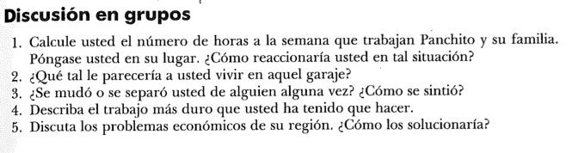

--------------------------------------------------------------------------------------------------

Avanzado (Advanced)
Instrucciones:
1) En grupos de 3-4 van a crear un video actuando su conversación.
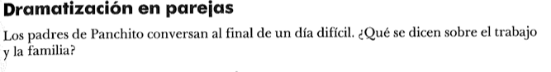
2) Escriban su diálogo en una hoja de papel o en Microsoft word.
3) Luego graben video en photo booth. Sean creativos.
4) Mandar el video a mi correo senorita.cabrera4@gmail.co
Rúbrica evaluadora
 | 0-1 | 2 | 3 | 4
Written Product | No written product | The response to the question lacks information and has many orthography and grammatical errors. It answers some questions. | The response to the question contains sufficient information but has some orthography and grammatical errors. It answers most questions. | The response to the question contains all information and has minimal has some orthography and grammatical errors that do not interfere with meaning. It answers most questions.
Presentation (Video or audio recording) | No Presentation | The presentation includes about 70 percent of the required elements.  Audio or video recording. | The presentation includes about 80 percent of the required elements.  Audio or video recording. | Itinerary contains all the required elements.  Audio or video recording.
Theme and relevance to the story | No relevance to reading or theme of story. | The video or recording is slightly related to the reading or story and does not reference the text. | The video recording is related to reading or story and references the text. | The video recording is related to reading or story and references the text with direct quotes.

