**Conversación informal (3 Summative grades)**

**Due date: All parts of the assignment are due April 6th**

***For this assignment you need to complete all 3 parts. Each is worth 1 summative grade.***

**Parte 1: Practicar con un compañero (Practice with a partner).**

Take turns practicing out loud with a partner. After you have practiced twice have your partner fill out the evaluation form. If you do not have someone to fill out the evaluation you will **not receive** a grade for this part.

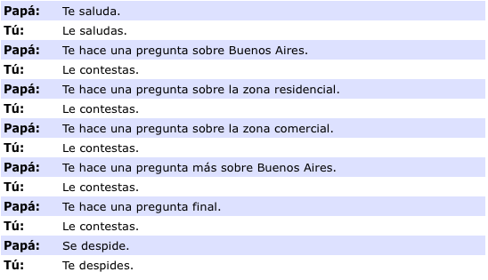------------------------------------------------------------------------------------------------------------------**Outline for simulated conversation**

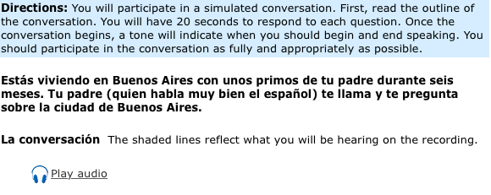

**Parte 2: Evaluación del compañero (peer review)**

**Person speaking:_________________________________ Person evaluating:______________________**

1. **Circle a score for each section:**

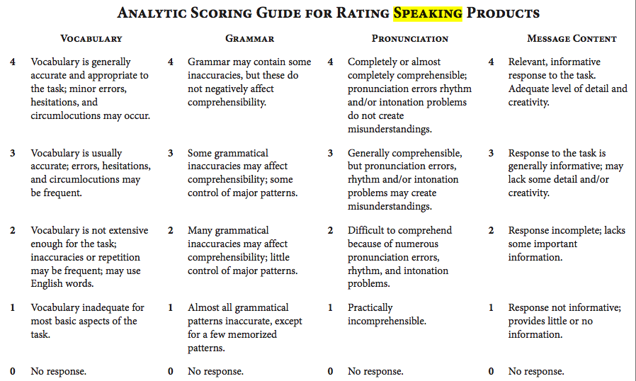

1. **What is their total grade based on the rubric? ¿Cuál es su calificación basado en la rúbrica? (Add total numbers and divide by 4)**

**Circle: 0 1 2 3 4**

1. **Why? ¿Por qué ? (3 sentences)**
2. **Evidence- Evidencia ( 3 examples from the conversation)**

**Part 2: Grabación (Recording)**

Record yourself using the audio provided on the weebly and google classroom. Make sure that you **can hear the audio** in your recording. Use the instructions and make sure you share a copy with Ms. Cabrera.

[Senorita.cabrera4@gmail.com](mailto:Senorita.cabrera4@gmail.com) or [cocabrera@laalliance.org](mailto:cocabrera@laalliance.org)

Macintosh HD:Users:Ms.Cabrera:Desktop:How to record sound on Mac 2. .pdf

**Parte 3: Evaluación personal (Personal evaluation)**

*Complete the self-evaluation at the end of the final recording.*

1. **What do you believe your grade should be based on the rubric? ¿Cuál piensas que debería ser tu calificación basada en la rúbrica?**

***Circle*: 0 1 2 3 4**

1. **Why? ¿Por qué ? (3 sentences)**
2. **Evidence- Evidencia ( 3 examples from the conversation)**
3. **Escribe algo que se te hizo difícil. Write something that was difficult.**
4. **Escribe una de tus fortalezas en esta actividad. Write one of your strengths for this activity.**
5. **¿Cómo te ayudará en la vida real? How will this help you in real life?**
6. **Think of one idea that could help you prepare for an assignment like this in the future. Piensa en una idea que puedes usar para preparar para un trabajo como este en el futuro.**